OUTPUT

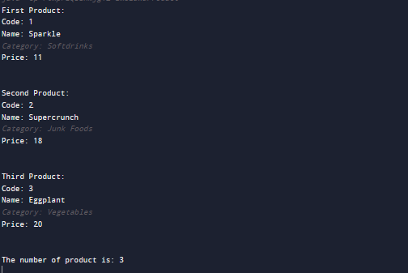

SOURCE CODE:

//AUTHOR: EMBLAWA< JOSHUA

//DATE: MARCH 11, 2023

//CLASSES AND METHODS

class EmblawaProduct {

private int code;

private String name;

private String category;

private int price;

private static int amount = 0;

//constructor

public EmblawaProduct(int code, String name, String category, int price) {

this.code = code;

this.name = name;

this.category = category;

this.price = price;

amount++;

}

//getter

public int getCode() {

return code;

}

public String getName() {

return name;

}

public String getCategory() {

return category;

}

public int getPrice() {

return price;

}

//static method

public static int getAmount() {

return amount;

}

//Print

public static void main(String[] args) {

EmblawaProduct product1 = new EmblawaProduct(01, "Sparkle", "Softdrinks", 11);

EmblawaProduct product2 = new EmblawaProduct(02, "Supercrunch", "Junk Foods", 18);

EmblawaProduct product3 = new EmblawaProduct(03, "Eggplant", "Vegetables", 20);

System.out.println("First Product:");

System.out.println("Code: " + product1.getCode());

System.out.println("Name: " + product1.getName());

System.out.println("Category: " + product1.getCategory());

System.out.println("Price: " + product1.getPrice()+"\n\n");

System.out.println("Second Product:");

System.out.println("Code: " + product2.getCode());

System.out.println("Name: " + product2.getName());

System.out.println("Category: " + product2.getCategory());

System.out.println("Price: " + product2.getPrice()+"\n\n");

System.out.println("Third Product:");

System.out.println("Code: " + product3.getCode());

System.out.println("Name: " + product3.getName());

System.out.println("Category: " + product3.getCategory());

System.out.println("Price: " + product3.getPrice()+"\n\n");

System.out.println("The number of product is: " + product2.getAmount());

}

}